Assignment 3

Q1. Produce a combine table in which each student is combine with every other application.

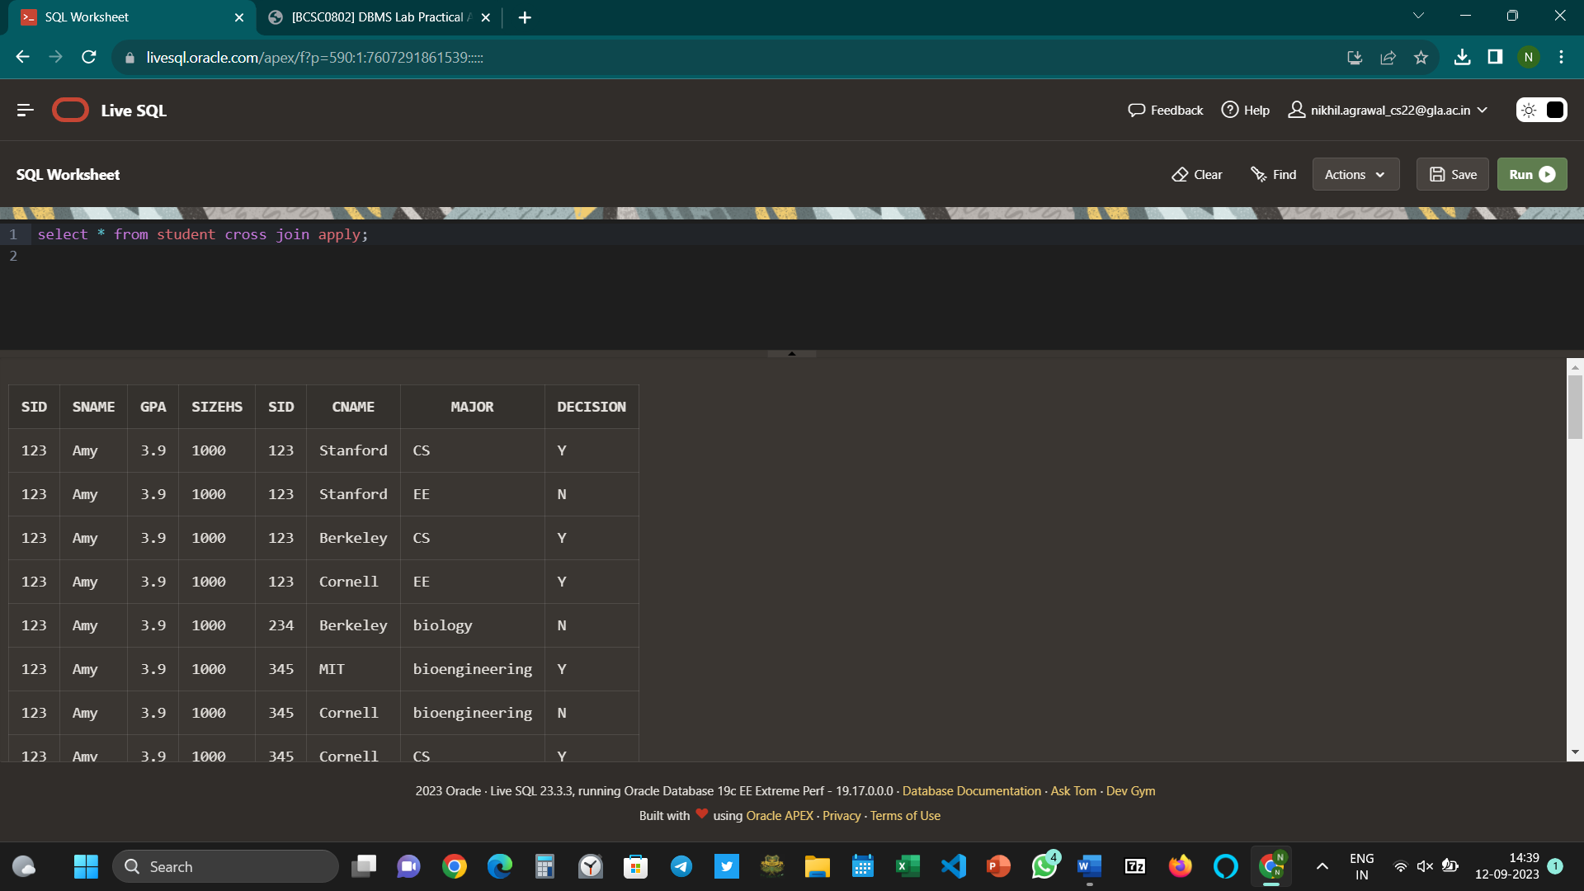

Q2. Give Student ID, name, GPA and name of college and major each student applied to.

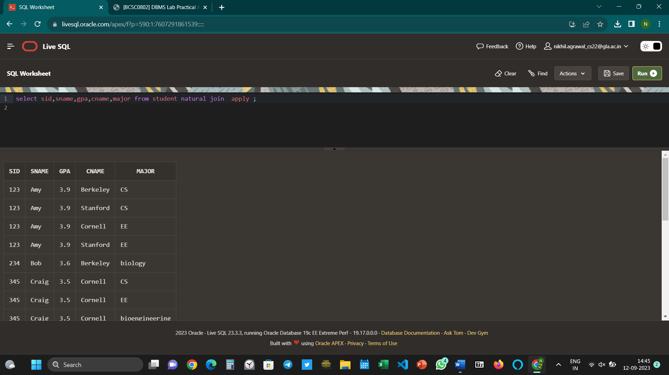

Q3. Find detail of applications who applied to California State.

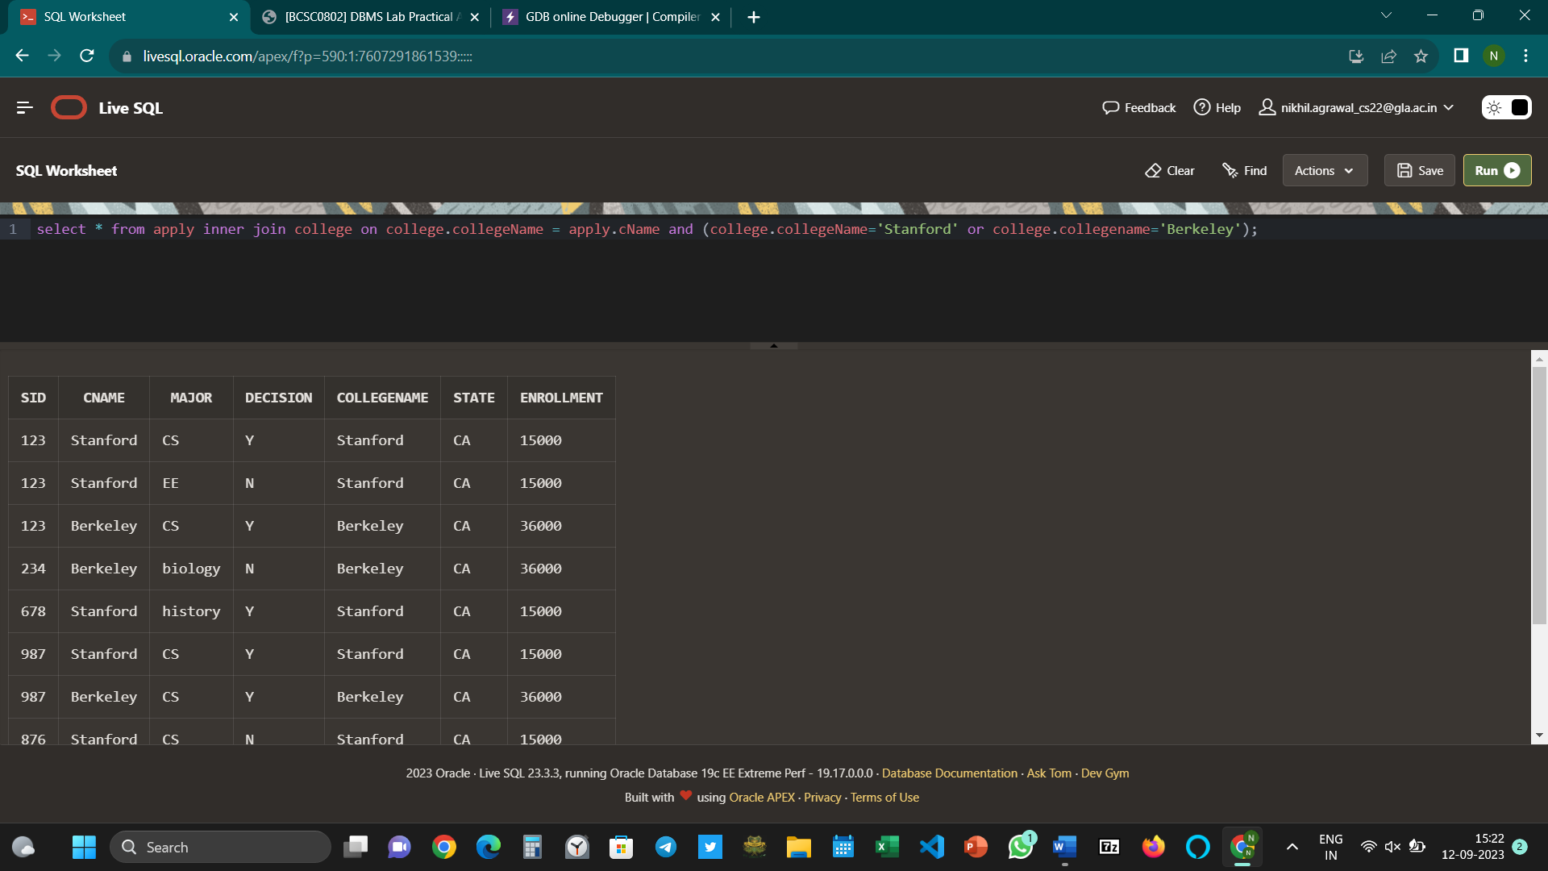

Q4. IDs, name, GPA of students and name of college with GPA > 3.7 applying to Stanford.

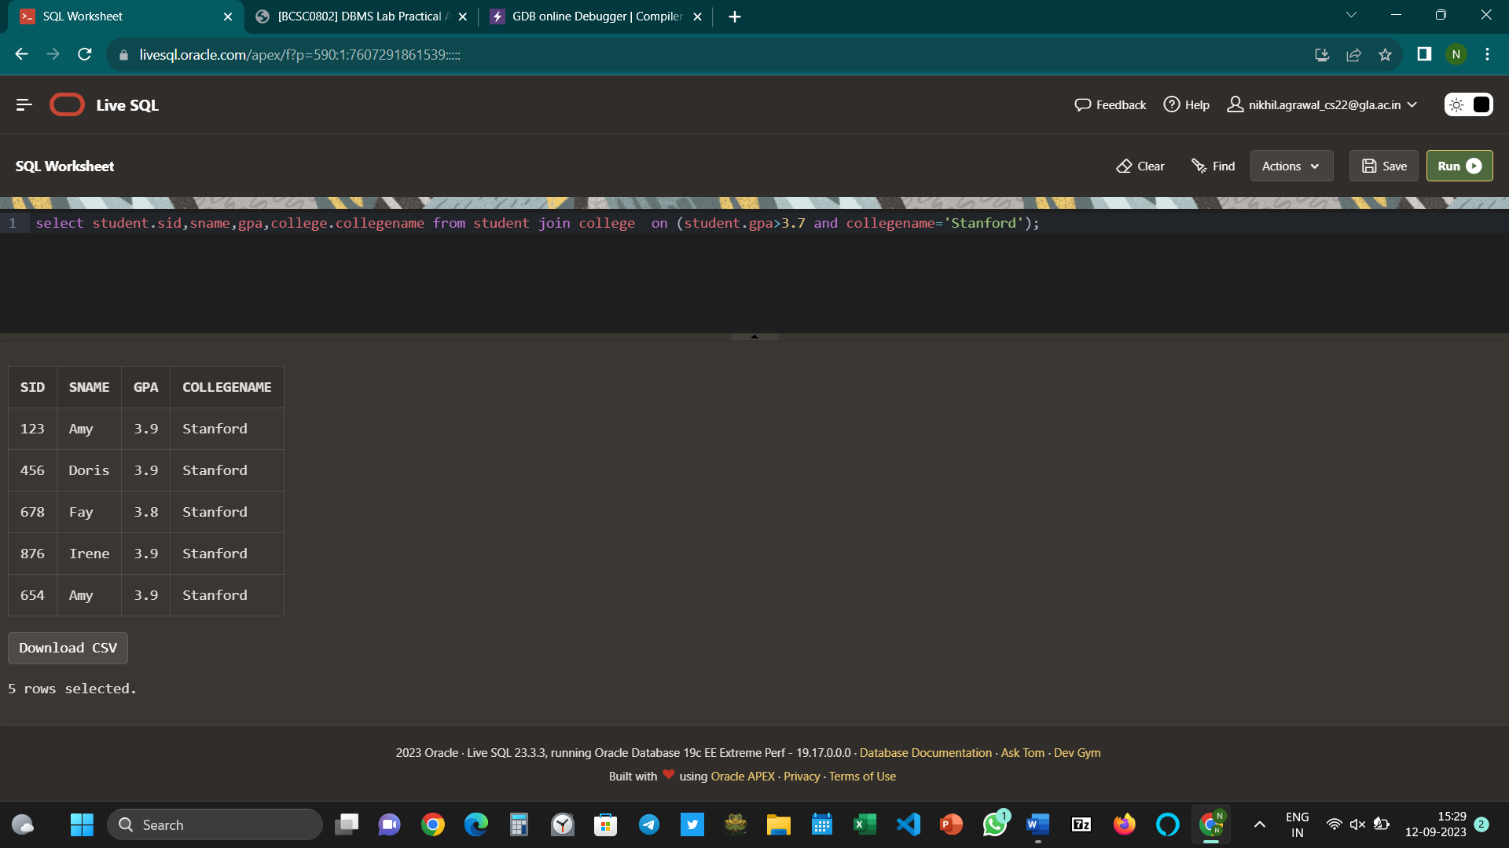

Q5. Find detail of Student who apply to CS major and their application are rejected.



Q6. Find detail of student and application who applied to colleges at New York

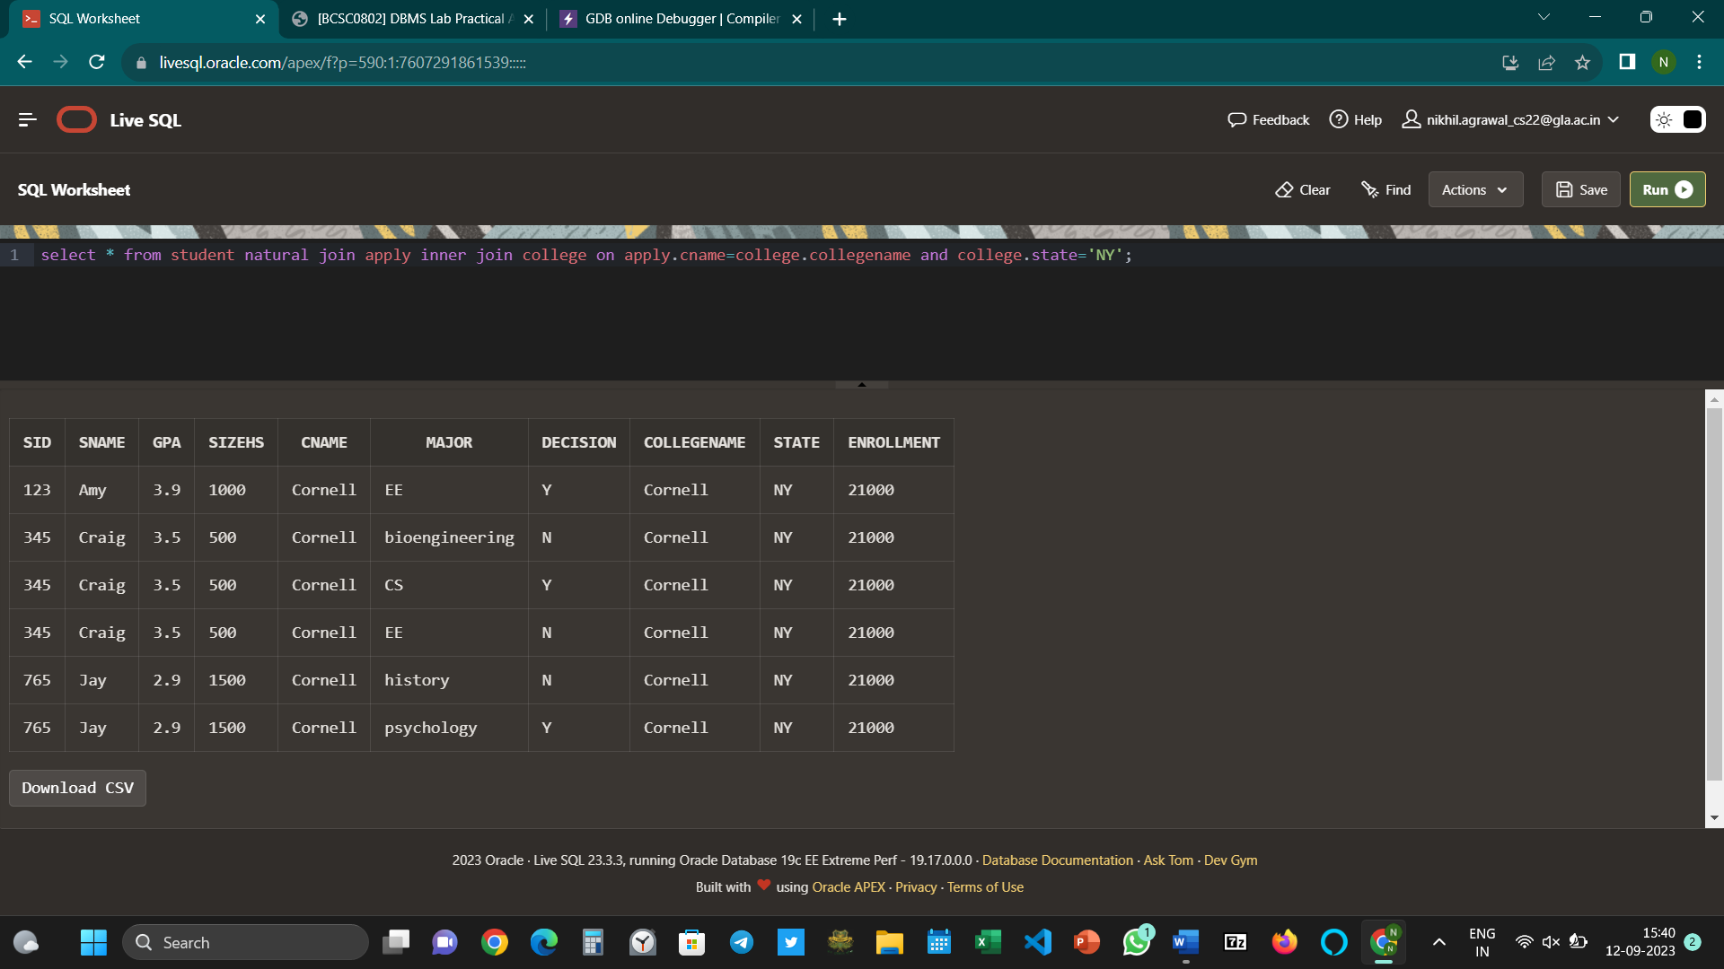

Q7. Find detail of student who have not applied to any of college.



Q8.Find college where no student have applied.



Q9. Find sID who have only one application.



Q10. Find name and GPA of applicants who apply to any college whose enrollment is not more than 25000.



Q11. Find pair of students (sID) having same GPA. (each pair should occur just once in result)



Q12. Find various majors student applied in at college in state MA.

